AI Assistant lab-17.3
Name: ADHI RISHAWANTH
Rollno:2303a52379
Batch:42
Task 1 Employee Dataset Cleaning
Task:
Use AI assistance to clean an employee information dataset. Instructions:
- Handle missing values in salary, designation, and experience
- Remove duplicate employee IDs
- Standardize text values (job titles in lowercase)
- Encode categorical features (designation, employment_type) Prompt :
Clean an employee dataset.

Instructions:
- Handle missing values in salary (median), designation (mode), and experience (mean)
- Remove duplicate records based on employee_id
- Convert designation text to lowercase
- Encode categorical columns: designation and employment_type
- Output the cleaned dataset with no missing values and encoded features Code :
import pandas as pd import numpy as np
from sklearn.preprocessing import LabelEncoder

# ---- Sample Dataset ---- np.random.seed(42)
df = pd.DataFrame({
"employee_id": np.random.randint(100, 200, 50), "name": [f"Emp{i}" for i in range(50)],
"salary": np.random.choice([30000, 40000, 50000, 60000, np.nan], 50), "designation": np.random.choice(["Manager", "Developer", "Analyst",
None], 50),
"experience": np.random.choice([1, 2, 3, 4, 5, np.nan], 50), "employment_type": np.random.choice(["Full-time", "Part-time",
"Contract"], 50)
})

# ---- 1. Handle Missing Values ----
df['salary'] = df['salary'].fillna(df['salary'].median()) df['designation'] = df['designation'].fillna(df['designation'].mode()[0]) df['experience'] = df['experience'].fillna(df['experience'].mean())

# ---- 2. Remove Duplicate Employee IDs ---- df = df.drop_duplicates(subset='employee_id')

# ---- 3. Standardize Text Values ---- df['designation'] = df['designation'].str.lower()

# ---- 4. Encode Categorical Features ---- le1 = LabelEncoder()
le2 = LabelEncoder()

df['designation'] = le1.fit_transform(df['designation']) df['employment_type'] = le2.fit_transform(df['employment_type'])

# ---- Output ---- print("Cleaned Dataset:") print(df.head())

print("\nShape:", df.shape)
print("\nMissing Values:\n", df.isnull().sum())
Output:
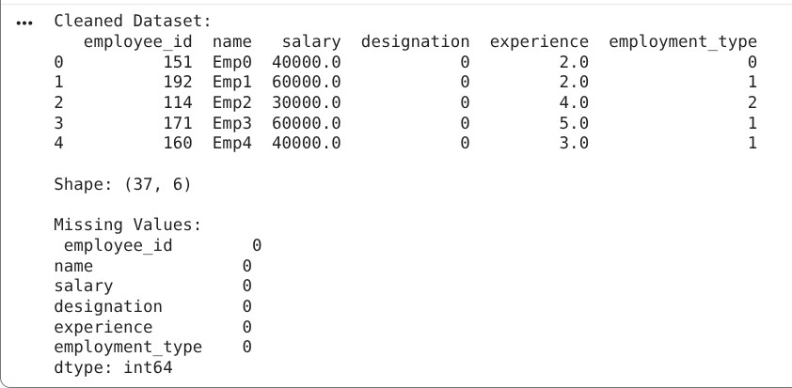
Justification:

  - Missing Values Handling
    - Salary → Median: Salary distributions are often skewed; median is robust to outliers.
    - Designation → Mode: Most frequent job title maintains categorical consistency.
    - Experience → Mean: Numerical field; mean preserves overall distribution.
  - Duplicate Removal
    - Removing duplicate employee_id ensures data integrity and avoids biased analytics.
  - Text Standardization
    - Converting designations to lowercase eliminates case-sensitive inconsistencies (e.g., “Manager” vs “manager”).
  - Categorical Encoding
    - Machine learning models require numerical inputs; encoding converts text into usable numeric form.
Task 2 – Student Performance Data Preprocessing Task:
Preprocess student performance data using AI assistance. Instructions:
- Convert exam_date column into datetime format
- Extract new features (month, semester, day)
- Normalize total_marks
- Detect and handle outliers in marks using IQR or Z-score Prompt:
Preprocess a student performance dataset.

Instructions:
- Convert exam_date to datetime format
- Extract new features: month, day, semester (1 for Jan–Jun, 2 for Jul–Dec)
- Normalize total_marks using MinMax scaling
- Detect and remove outliers using IQR method
- Output the transformed dataset with new features and normalized marks Code:

import pandas as pd import numpy as np
from sklearn.preprocessing import MinMaxScaler

# ---- Sample Dataset ---- np.random.seed(0)
dates = pd.date_range(start="2024-01-01", periods=60)

df = pd.DataFrame({ "student_id": range(1, 61),
"exam_date": np.random.choice(dates, 60),
"total_marks": np.random.randint(200, 1000, 60)
})

# Add some outliers
df.loc[5, 'total_marks'] = 1500 df.loc[10, 'total_marks'] = 50

# ---- 1. Convert exam_date to datetime ---- df['exam_date'] = pd.to_datetime(df['exam_date'])

# ---- 2. Extract Features ---- df['month'] = df['exam_date'].dt.month df['day'] = df['exam_date'].dt.day
df['semester'] = df['month'].apply(lambda x: 1 if x <= 6 else 2)

# ---- 3. Normalize total_marks ---- scaler = MinMaxScaler()
df['total_marks'] = scaler.fit_transform(df[['total_marks']])

# ---- 4. Detect & Remove Outliers (IQR) ---- Q1 = df['total_marks'].quantile(0.25)
Q3 = df['total_marks'].quantile(0.75)
IQR = Q3 - Q1

df = df[(df['total_marks'] >= Q1 - 1.5 * IQR) & (df['total_marks'] <= Q3 + 1.5 * IQR)]

# ---- Output ---- print("Processed Dataset:")

print(df.head())

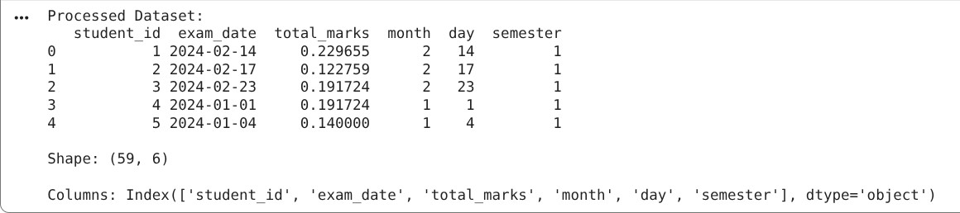
print("\nShape:", df.shape) print("\nColumns:", df.columns) Output:

Justification:

  - Datetime Conversion
    - Enables time-based feature extraction and chronological analysis.
  - Feature Extraction (month, day, semester)
    - Captures academic patterns and seasonality (e.g., exam trends across semesters).
  - Normalization (MinMax Scaling)
    - Scales marks to a uniform range (0–1), preventing feature dominance in ML models.
  - Outlier Removal (IQR)
    - Eliminates extreme values that can distort model training and statistical analysis.

Task 3 – Student Health Data Preparation Task:
Clean and preprocess student health records using AI scripts. Instructions:
- Handle missing values in height, weight, BMI
- Encode categorical features (medical_condition, fitness_status)
- Scale numerical features using standard scaling
- Split dataset into training and testing sets Prompt:

Prepare a student health dataset for machine learning.

Instructions:
- Handle missing values in height, weight, and BMI using mean
- Encode categorical features: medical_condition and fitness_status
- Apply standard scaling to numerical features (height, weight, BMI)
- Split dataset into training and testing sets (80-20)
- Output processed dataset ready for modeling Code:
import pandas as pd import numpy as np
from sklearn.preprocessing import LabelEncoder, StandardScaler from sklearn.model_selection import train_test_split

# ---- Sample Dataset ---- np.random.seed(1)

df = pd.DataFrame({ "student_id": range(1, 51),
"height": np.random.choice([150, 160, 170, 180, np.nan], 50),
"weight": np.random.choice([50, 60, 70, 80, np.nan], 50),
"BMI": np.random.choice([18, 22, 25, 30, np.nan], 50), "medical_condition": np.random.choice(["None", "Asthma", "Diabetes"],
50),
"fitness_status": np.random.choice(["Fit", "Unfit"], 50)
})

# ---- 1. Handle Missing Values ----
df['height'] = df['height'].fillna(df['height'].mean())
df['weight'] = df['weight'].fillna(df['weight'].mean())
df['BMI'] = df['BMI'].fillna(df['BMI'].mean())

# ---- 2. Encode Categorical Features ---- le1 = LabelEncoder()
le2 = LabelEncoder()

df['medical_condition'] = le1.fit_transform(df['medical_condition']) df['fitness_status'] = le2.fit_transform(df['fitness_status'])

# ---- 3. Scale Numerical Features ---- scaler = StandardScaler()
df[['height', 'weight', 'BMI']] = scaler.fit_transform(df[['height', 'weight', 'BMI']])

# ---- 4. Train-Test Split ----
X = df.drop('fitness_status', axis=1) y = df['fitness_status']

X_train, X_test, y_train, y_test = train_test_split(X, y, test_size=0.2)

# ---- Output ---- print("Processed Dataset Sample:") print(df.head())

print("\nTrain Shape:", X_train.shape) print("Test Shape:", X_test.shape)
Output:
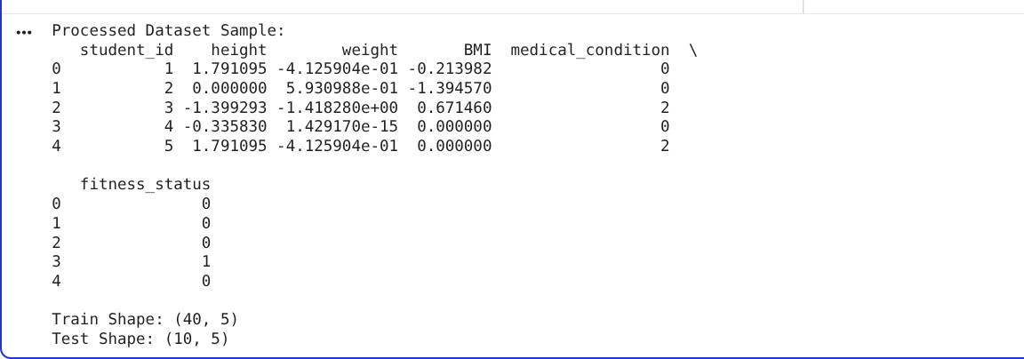
Justification:
  - Missing Value Imputation (Mean)
    - Maintains dataset size while preserving average distribution of health metrics.
  - Categorical Encoding
    - Converts health conditions and fitness status into numerical form for predictive modeling.
  - Standard Scaling

    - Centers data (mean=0, std=1), essential for algorithms sensitive to feature magnitude (e.g., SVM, KNN).
  - Train-Test Split
    - Separates data to evaluate model performance on unseen data, ensuring generalization.

Task 4: Real-Time Application: Ride-Sharing Data Cleaning Scenario:
A ride-sharing company has trip data with errors. Requirements:
- Standardize pickup and drop locations
- Fill missing fare amounts with median values
- Remove duplicate ride entries
- Normalize driver ratings
- Generate a summary of data improvements Prompt:
Clean a ride-sharing dataset.

Instructions:
- Standardize pickup and drop locations to lowercase
- Fill missing fare values using median
- Remove duplicate records based on ride_id
- Normalize driver_rating using MinMax scaling
- Generate summary of cleaning steps and final dataset Code:
# Task 4: Ride-Sharing Data Cleaning

import pandas as pd import numpy as np
from sklearn.preprocessing import MinMaxScaler

# ---- Sample Dataset ---- np.random.seed(2)

locations = ["Chennai", "Adyar", "T Nagar", "Velachery", "Tambaram"]

df = pd.DataFrame({
"ride_id": np.random.randint(1, 40, 60),
"pickup": np.random.choice(locations, 60),
"drop": np.random.choice(locations, 60),
"fare": np.random.choice([100, 150, 200, 250, np.nan], 60),
"driver_rating": np.random.uniform(3.0, 5.0, 60)
})

# Introduce inconsistencies df.loc[0, 'pickup'] = "chennai" df.loc[1, 'drop'] = "adyar"

# ---- 1. Standardize Locations ---- df['pickup'] = df['pickup'].str.lower()
df['drop'] = df['drop'].str.lower()

# ---- 2. Handle Missing Fare ----
df['fare'] = df['fare'].fillna(df['fare'].median())

# ---- 3. Remove Duplicate Rides ---- before_count = len(df)
df = df.drop_duplicates(subset='ride_id') after_count = len(df)

# ---- 4. Normalize Driver Ratings ---- scaler = MinMaxScaler()
df['driver_rating'] = scaler.fit_transform(df[['driver_rating']])

# ---- 5. Summary ---- print("CLEANED DATASET SAMPLE:")
print(df.head())

print("\nSUMMARY:")
print("Records Before Cleaning:", before_count) print("Records After Removing Duplicates:", after_count) print("Missing Values:\n", df.isnull().sum())
Output:

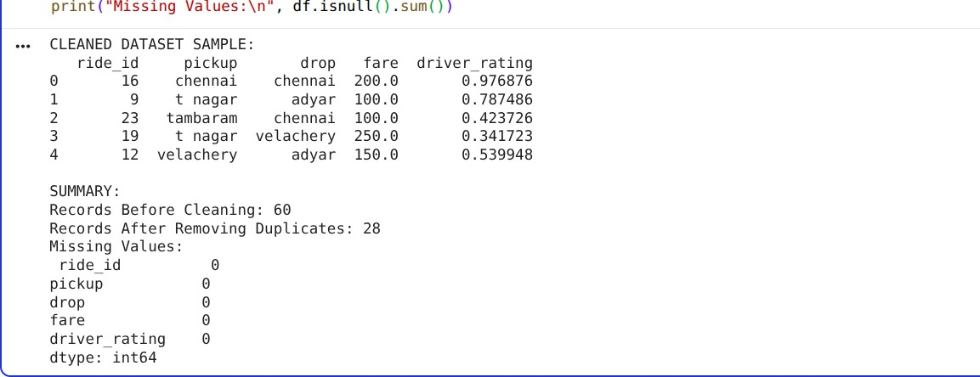
Justification:
Location Standardization
  - Ensures consistent grouping and analysis (e.g., “Chennai” vs “chennai”).
Missing Fare Imputation (Median)
  - Median prevents distortion caused by unusually high/low fares. Duplicate Removal
  - Avoids repeated ride entries, ensuring accurate operational metrics. Rating Normalization
  - Scales ratings for fair comparison and compatibility with ML models. Summary Generation
  - Provides transparency and validates improvements in data quality.

